**Vision Statement**

**Croft Farm Foods**

* To manage the business more effectively using an efficient computer system. (Main)
* To implement an efficient computer system to accommodate for different groups to work cohesively.

(May be more specific vision statements related to goals)

<http://www.lifehack.org/articles/work/20-sample-vision-statement-for-the-new-startup.html>

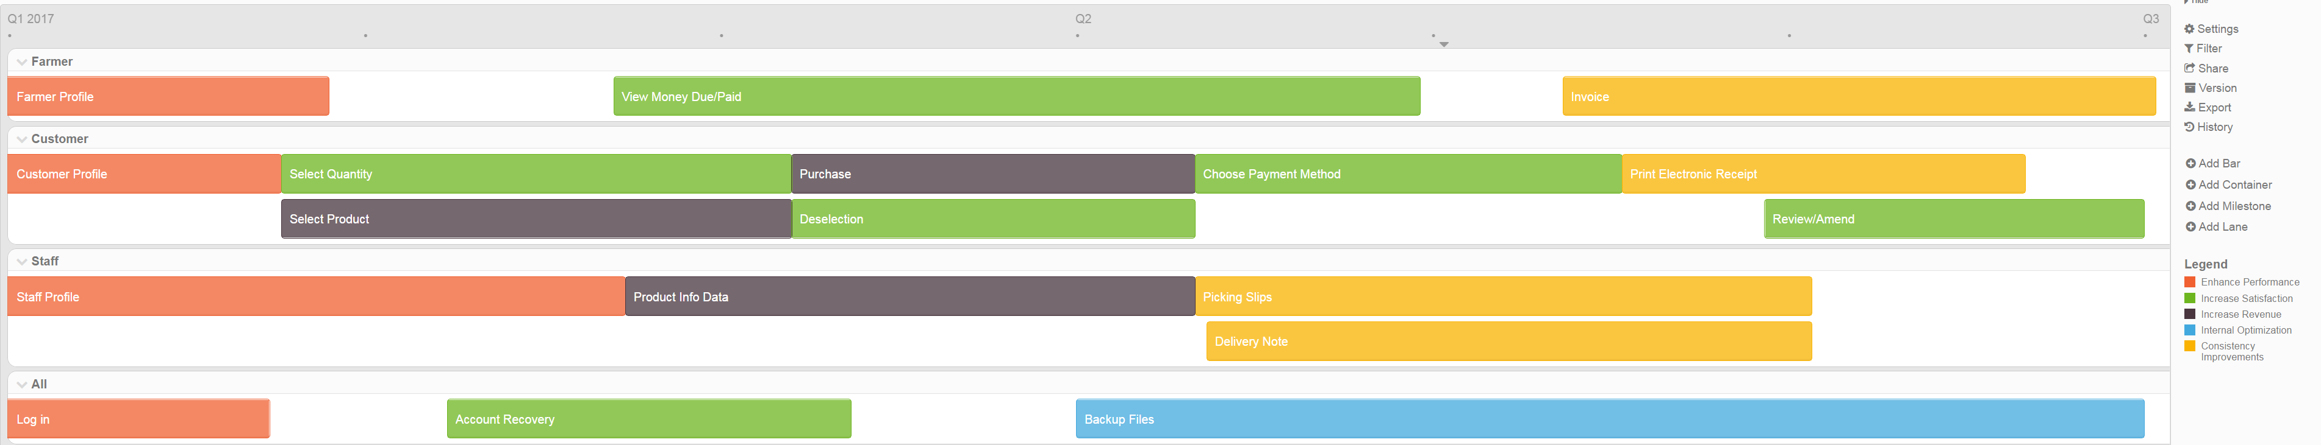

https://www.productplan.com/what-is-a-product-roadmap/